Print and post review
  - September to November 2022
  - Final report May 2023

Table of Contents
Executive Summary 1
Context 2
Project approach 2
Summary of recommendations, recent changes and future opportunities 2
Print and post activity and costs 3
Service specific print and post activity 7
Revenues and Benefits 7
Democratic Services 8
Parking Management 10
Economy, Planning and Strategic Housing 10
Princes Hall 11
General printing opportunities & recommendations 12
Other notes 12
Appendices 13
Appendix I | High level summary to high volume print and post activities 14

Executive Summary

Context
This report summarises current high-volume print and post service activities, including recent changes and reductions to those activities and future opportunities for change that may improve services and/or reduce costs.

Project approach
The working group was set two objectives:
- To research and validate the nature and need for significant printing and posting activity across our services.
- To identify opportunities and recommend actions that will deliver improvements and/or savings in these activities.
The achieve this the Post and Print working group set a target of reviewing 80% of their service's relevant activity by printing and postage volumes. This was achieved by:
- Accounting for 80% or more of the print and post activity captured in our datasets for printing, taken from the PaperCut print management software, and for post, using data captured by Customer Services and postal franking and services reports.
- Identifying the corresponding activity; the need for the activity as required by law, procedure, process or preference; document and letter formats, sizes and content; use of equipment and manual handling processes;
- Identifying underlying the costs of these activities based on and cross referenced with information from finance relating to print and post fees, charges, equipment leasing and relevant pricing models.
This created picture of volumes relating to specific business/service activities. A high-level snapshot of this information is included in appendix I. The group then applied check and challenge to the necessity, volume and means of these activities in search of cost reduction options.

Note on scope
The following items were outside of the project scope, and so have not been investigated by the working group:
- Achieving changes by implementation of new software or hardware;
- Alteration or procurement of existing or new contracts respectively;
- Investigating bespoke, low volume internal printing activities;
- Electronic or physical document storage.

Summary of recommendations, recent changes and future opportunities
Our recommendations, agreed with the relevant services and validated by Finance, are:
- An internal communications campaign to change staff behaviours with the aim to reduce printing and postage costs by 10% (up to £10k). This could include transitioning from post to other communication channels, sharing data, cost saving guidance, use of technology, removing some printers from the offices, and encouraging services to review, reduce and even cease some postage practices.
- A campaign to move more residents onto council tax e-billing, through active promotion in outgoing calls, as well as the usual passive comms, which could save up to £20k by making email the default billing channel. A successful campaign may lead to a further saving of up to £10k on annual billing.
- Design a digital alternative to replace planning neighbour notices and community involvement letters that could save up to £10k. The collection of email addresses for council tax e-billing could support this, subject to data protection compliance.
- Review the value proposition of the internal print service and consider whether there is a business case for change (low thousands).
Through this review, information on print and post activity has been shared with the services involved. As a result, services have already begun to identify and make changes to reduce costs, including the following significant changes:
- Adding further content to annual council tax bills to allow us to stop sending council tax support notifications letters. This will save around £15k from our annual postage costs.
- Ceasing the manual checking of revenue and benefit documents from 1st December. This results in a saving of £9k, which has already been counted as a cost reduction.
- Reducing planning neighbour notices to just nearest neighbours and considering reducing other discretionary post. 16,572 associated letters were sent in 2021/22 and so there is potential for significant reductions in postage costs. It is currently too early, however, to assess the extent and financial impact of this change.

Print and post activity and costs
A complete picture of print and post activity at RBC is composed of internal activities performed by service and support teams, and external activities wherein printing and postage are performed by an external supplier sourced via procurement. External activities typically have a simple cost figure covering the package of print and post services delivered. Internal activities have various cost items arising from the range of print hardware and formats used, the differing document creation and manual handling arrangements and variable postage cost of different letter formats and volume discounts.
Internal printing activity is monitored by the PaperCut print management software. From this data we see a picture of print activity changing over time, and this is a fair reflection of postage activity. This shows clear peaks and troughs associated with specific large-scale activities by the services, as noted below:
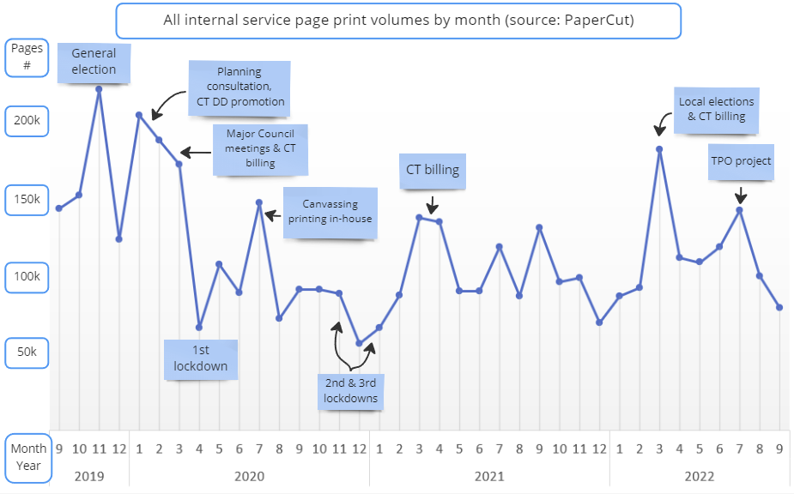Figure 1: internal print volumes by month Sept 2019 to Sept 2022.
In the financial year 2021/22 the Council printed 1.3 million pages and sent out 194,000 letters. Print and post activity cost in the region of £129,000, the majority of which arise through postage costs.
The split of this activity across our services is shown below with three services accounting for over half of this activity.
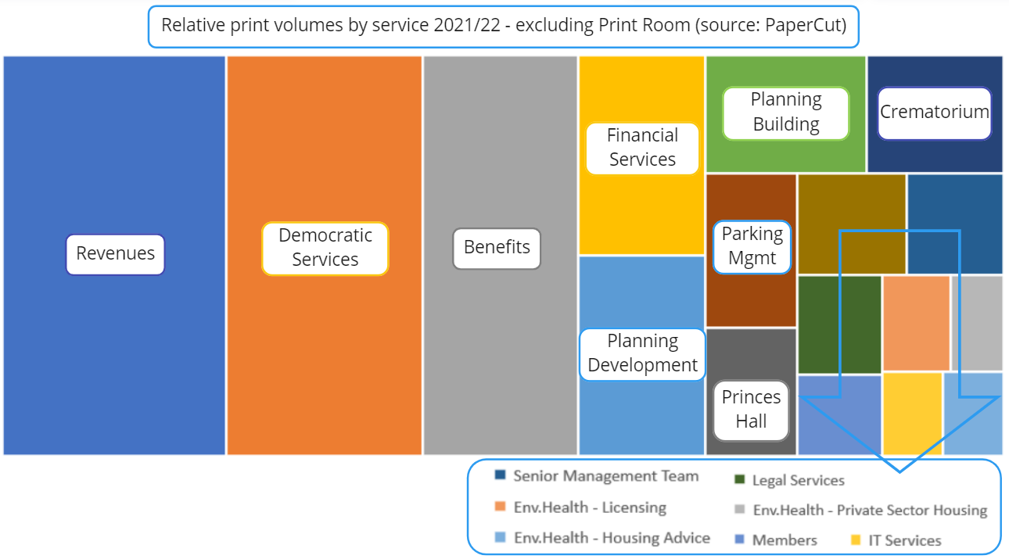Figure 2: Relative print volumes by service in 2021/22

Components of cost
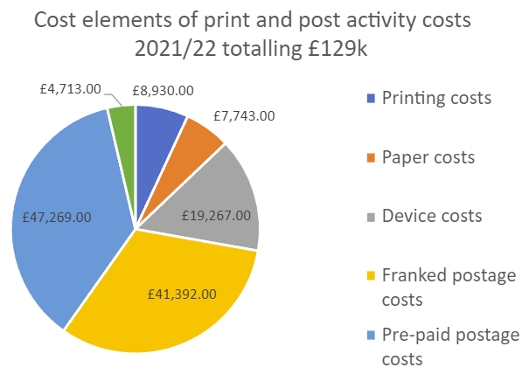
Figure 3: Cost elements of print and post activities in 2021/22
The costs of print and post activities also arise from fix costs, such as the leasing cost of printers and hardware, and fees arising from usage, such as pages printed, and letters posted. Indirect costs arise in the form of staff time involved in processing and handling documents and letters. Furthermore, some costs are difficult to directly attribute to specific print and post activities due to the complexity of staff time use, variations in the lease cost of different models of device and the shared nature of charges, such as printer lease costs.

Kyocera devices
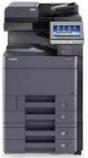 | Most printers used by staff on the floors of Rushmoor’s offices are provide under lease by contract with Kyocera Document Solutions. The leased devices are as follows:  - 7 x TASKalfa 4012i monochrome printer/scanner  - 5 x TASKalfa 4053ci colour & monochrome printer/scanner  - 2 x TASKalfa 3253ci colour & monochrome printer/scanner  Left: a TASKalfa 4053ci
These 14 devices account for around 60% of all printing. The annual lease cost of these devices is £9,424.

Konica Minolta devices
Konica Minolta lease Rushmoor in two ‘high volume’ printers used in the Print Room that provide for volume print at a higher speed as well as professional quality and finishing options, such as maybe needed for external publications/promotional material:
- The BizHub Prob 1100 is a high volume, high speed black & white multifunctional printer. This device accounts for around 33% of all printing. The annual lease cost is £2,236.
- AccurioPress C3070 is a high speed colour, black & white multifunctional printer. This device accounts for just 4% of all printing. The annual lease cost is £6,705.

Other printers
Three other devices are in use via separate lease arrangements providing for specific niche printing use cases. These devices however account for less than 3% of all printing with lease costs totalling £1,358.

Franking machine
Customer Services lease a franking machine from Quadient. This machine is used to apply 1st and 2nd class postage to outgoing letters. Customer Service receive letters from various service teams and attempt to batch them, in coordination with service teams, as effectively as possible to minimise postage costs. This form of postage is significantly cheaper than using stamps; at time of review: 1st class stamp 95p, 2nd class stamp 68p vs franking machine 1st class 78p, 2nd class 51p.
The franking machine annual lease cost is £3,913.

Print management software
Rushmoor us PaperCut print management software, in conjunction with the contracted printing services, to manage and capture printing usage. PaperCut is the data source for the printing data in this report and provides details of print-jobs and volumes with a range of meta data, allowing breakdowns by service areas, users and printing formats.
PaperCut is used under licence with an annual cost of £800

Projecting costs and savings in relation to specific print and post activities
To enable practical means of attaching a ‘cost’ to any Service’s particular print and post activities, this review has established scalable working figures that might be used to project savings. These figures are based, in part, on the Kyocera print services contract costs which relate to over 92% of print activity at Rushmoor. These calculations enable us to focus on direct costs that are both realistic and can be attributed to specific print and post activity, as follows:
- Printed pages costs comprising paper and printing:
  - £0.026 per colour page = £0.02 for a colour print + £0.006 for one A4 paper sheet
  - £0.008 per black & white page = £0.002 for monochrome print + £0.006 A4 paper
- Postage costs:
  - £0.43 per letter = £0.40 for 2nd class postage via pre-paid impression + £0.03 for the DL black and white envelop pre-paid envelope. This is the cheapest form of postage.
These figures underpin projections for potential savings arising directly from changes in activity. For example, ceasing to print 1000 black and white pages saves £8.00 (1000 x £0.008). Ceasing to post 1000 letters saves £430 (1000 x £0.43). As this example shows, postage alone typically accounts for 91% of the total cost of a printing and sending a letter.
Note that the calculations above do not attempt to cover printer contract maintenance and lease costs, software costs or staff time in the corresponding activity. They do however allow calculation of real savings that will be directly recouped in the associated print and post activity stops.

Service specific print and post activity
The service specific figures in this report are based upon data for the financial year 2021/22, unless stated otherwise. Any unusual variances in the year are noted in the service specific sections that follow.

All services 2021/22 internal print & post volumes & costs
- 1.3m pages were printed at the council offices at a cost of £34,804 inclusive of contract lease and maintenance charges.
- 233 bespoke printing jobs were handled by the Print Room with a recharge cost to client services totalling £17.7k.
- 79,634 outgoing postage items franked at a total cost of £41,392.
  - 81% 2nd class costing £31,832
  - 18.5% 1st class costing £12,359
    - At least 63% / £7,786 of which is mandated by legislation
- 115,080 ‘pre-paid impression’ (PPI) envelopes were used at a cost of £47,269

Revenues and Benefits

Overview
Revenue and Benefits produce a large range of documents subject to legal requirements. As seen in figure 2, around a third of all printing at Rushmoor arises from these service areas. Print and post activity involves a combination of internal and external service providers. Most outgoing post sent from the offices uses the cheapest form of postage – prepaid impression (PPI) envelopes, sent via Customer Services. This accounts for 74% of all PPI envelopes use.

Changes in activity
- Following this review, the Service has identified and acted upon an opportunity to add further content to annual council tax bills and so allow Rushmoor to stop sending council tax support notifications letters. This will save around £15k from our annual postage costs.
- Council Tax e-billing is now offered by Rushmoor providing a route to avoiding the significant postage cost element in billing letters. In 2021, the Service had 39,919 billable accounts, of which 2,378 accounts had signed up for e-billing with a saving estimated at just over £1k.
- Electronic document storage was introduced during the pandemic in April 2020. This has led to a reduction in the printing of documents for hardcopy record keeping.

Required activity
- Revenues and Benefits are the largest print and post using service by both volume and cost. Over 95% of the documents they print relate to statutory notices and, of these, at least 40% of the associated letters may not be sent via email.
- As a service that contacts all residents and is subject to significant directives from central government, the service often has significant unforeseen requirements to meet which drive up print and post activity and costs. This can be seen in the example of the energy rebate initiative which resulted in the production of 7,000 letters initially and a further 2,000 reminder letters, all produce and sent internally.

Opportunities

Use of SMS to avoid letters: The Service currently posts reminder letters for unpaid instalments along with subsequent reminders and summons. Some Councils have tried to reduce the need for such reminders by sending an SMS/text message reminder in advance in hope to avoid needing a letter. Based on the experience of other councils using this approach, we might avoid sending 20% the approx. 17k letters involved with the use of such SMS messages. This, with SMS costs accounted for, could save around £500.

Increasing E-Billing uptake: Only 6% of our ~40k billable accounts have signed up for e-billing, which does not reflect the proportion of email using residents seen across the services. Setting up eBilling currently requires a customer to have registered for an online Council account and to have selected the electronic billing option. A campaign to move more residents onto council tax e-billing could save up to £20k. This might be achieved by making e-billing the default billing method for new accounts, actively promoting sign-up via outgoing calls and use of Rushmoor’s usual passive communications, such as promotion in emails and via the website. A successful campaign may lead to a further saving of up to £10k on annual billing.

Sales Ledger invoicing: The Service prints and sends around 2.5k sales ledger invoices annually and feel, in many cases, this may be avoided by taking payments upfront to avoid invoicing altogether. This would reduce postage costs but is dependent upon affecting changes to client payment behaviours. A saving figure has not been projected due to the uncertainty at this time of uptake.

Democratic Services

Overview
Democratic Services produce high numbers of documents supporting the local electoral cycles and the electoral register, making them the second largest service in terms of print volumes. There are legal rules on communication methods for these documents and constraints also arise from the Electoral Management software involved. The service makes use of internal and external printing/printers and delivery of certain documents via canvassers as well as standard postal services.
95% of documents are printed as a legal requirement and the remainder are printed for practical purposes that as yet cannot be delivered via digital alternatives. 1st Class postage is used for just under 7% of letters where needed for key forms, such as postal vote applications, that must reach voters in specific timescales.
The ‘Elections Group’ of members are informed of upcoming changes in legislation and Democratic Services’ activities and give input to how these changes are made and managed.

Changes in activity
- In May 2023 the 66k+ poll cards the service produce will be changing format to A4 letters, featuring a QR code, and sent in envelopes. These will be printed & posted externally. Extra funding has been offered to cover the increase in costs in at least the first year.
- 37k+ canvassing emails have been sent via Gov.Notify in place of sending of Household Enquiry form letters. An estimated 8k properties responded to those emails in 2022, each of which avoids the need for canvassers to deliver these letters by hand.
- Around 13k absent voters need ‘refreshing’ in a process usually spread over five years. New rules will require this ‘refresh’ over three years so increasing the annual work involved with effect from Dec 2023. Democratic services a ready and able to use of email in Absent Voter refresh communications but legislation and the Electoral Management System prevent this.

Required activity
- 82% of the Service’s document printing relates to legally required forms and documents that must be delivered to the property. Wherever possible the service seeks more cost-effective delivery options. For example, Household Enquiry Forms are sent via Gov.Notify where a household has an attached email address, saving around £570 in postage costs.
- Election day operations require around 30k documents, most of which are specific to the event and so cannot be re-used. Unused documents & signs are reused wherever possible. Electronic solutions for these settings are expensive and are still typically backed up by hardcopy due to the risk of technology failing. Preparations for elections also involve large volumes of unavoidable printing, such as the printing of nomination papers and registers which exceeded 173k pages for the May 2021 elections.
- Bulky external print at post activities are always subject to procurement by acquiring three written quotes to ensure value, as per procurement rules, with a price also coming from our internal print room.

Opportunities

Empty property poll cards: Close to 6k ‘empty property’ poll cards are sent each year, costing around £240 to produce and £1184 for delivery by canvassers. This is generally done every year where all electors are eligible to encourage voter participation. This activity is recommended but not legally required.

Digitise agent packs for the election ballet paper Count: At the last Count event, packs were produced for 81 attending agents which were sent 1st class. The direct costs involved are not large (~£100), but this could be done by email if the Election Management System would support this. Electoral services are requesting this enhancement to be made.

Parking Management

Overview
73% of documents printed by Parking Management relate to Penalty Charge Notices (PCNs) and their printing and postage is required by statute. Legislation also includes specific rules on communication methods relating to PCNs including rules on postage class resulting in 99% of letters being printed and sent 1st Class in the same day. Customer Services is used for printing and posting via the in-house franking machine. 90% of PCN challenges are received via email and email communication is used in their resolution where possible. Some customers will also send emails of supporting documents.

Changes in activity
- The introduction of the web portal supporting digital service transactions in 2020 has resulted in significant shift in channel use for PCN resolution. In 2021/22 however, around 25-30% of challenges were still made in writing (not digitally). Each PCN challenge may have required the printing of 3 to 5 colour photos. The facility to challenge PCNs digitally avoids significant colour printing and the team believe digital uptake is increasing such that now 90%+ of challenges are digital.

Required activity
- Statutory notices, which currently account for over 80% of the service’s printing and post activity. Prompts encouraging people to use digital channels is already built into Parking Management processes and communications and remaining postal contact nearly always unavoidable.

Opportunities
Hampshire parking enforcement: On-street enforcement accounts for around 60% of enforcement activities and associated communications. This work will move to Hampshire on 1 April 2023 so a reduction statutory document throughput in the order of 60% might be expected but the impact has cannot been estimated in detail at this time. In the context of this report, those considering how to meet future internal demand for print and post activities arising from this service should consider the impact of this change.

Economy, Planning and Strategic Housing

Overview
Planning Services produce a range of notification documents as required under law and as requested by non-digital service users. Printing is performed in-house with high volume jobs directed to the Print Room. Outgoing post is franked by Customer Services.
Building Control’s partnership working with Hart DC historically required the printing of all Hart DC application documents, significantly increasing printing activity, and some technical barriers remain that might reduce the need to print plans. A potential move to Idox Cloud may further reduce printing. Regardless, Building Control fully recover the cost of their services and so direct cost saving from reduced printing are unlikely. Printing is largely in-house with larger plans requiring use of large paper size printer/plotter. Outgoing post is franked by Customer Services.

Changes in activity
- A 2021 integration with Planning Portal has reduced the need for printing of Rushmoor planning applications which now go straight into the planning system.
- Planning have begun reducing neighbour notice numbers by send these to just the nearest neighbours. 16,572 associated letters were sent in 2021/22 and so there is potential for significant reductions in postage costs. It is currently too early, however, to assess the extent and financial impact of this change.
- Conservation area review meetings have switched to virtual/online meetings. This is part of a wider change in meeting formats that have reduced printing volumes.
- A ‘Tree project’ reviewing Tree Preservation Orders began in July 30th 2022. This has increased printing in the service as it creates 250+ information packs of around 25 pages each in support of 430 tree surveys. The team are investigation potential to digitise this work in the future and are checking legislation,

Required activity
- Until changes to the systems supporting Hart DC’s planning processes are made, an estimated 70% of planning’s printing activity will remain necessary.

Opportunities

Opportunity: The council’s statement of community involvement commits us to letter-based communication. Associated costs vary, reflecting the surrounding property situation of each site concerned. This communication approach could be changed to reduce print and post based communication. This would require consultation with Members to discuss the implications of such a change. The financial impact of this change cannot therefore be projected at this time.

Princes Hall

Overview
Princes Hall’s print and post activity supports its income generation both through ticket sale processes and promotion of the venue. The Spektrix ticketing system has over 80,000 users of which around close to half use email and 75% live within the borough. Email is used for contact wherever possible. Print and post activity involves a combination of the Print Room with post via Customer Services as well as external printing service provider ‘HelloPrint’.
Of the 31k customers actively booking with Princes Hall in the last five years, 46% welcome marketing via email and 29% by post.

Changes in activity
- The twice-yearly brochure mail out was reduced from 25,000 brochures printed and 18,000 posted in 2016 to 8,000 printed and 4,000 posted today. This has been achieved via selection of a more targeted segment of properties, with an estimated saving of £13,650 delivered.

Required activity
- The return on investment of marketing activities is regularly reviewed. These activities are currently considered indispensable to Prince Hall’s profitability.
  - For example, the ‘Whats on’ brochure for Spring 2022 cost around £2,584.30 and ticket sales of the related events raised £47,681.25.
- Costs associated with the printing and delivery of tickets are recovered through ticket sales. Physical tickets are in many cases required or preferred but customers and the value of any saving in moving to eTicketing only is not considered worth the imposition for customers & customer service activities.
- Show’s attracting older demographics lead to increased preference for hardcopy. The Spektrix sign-up process aims to encourage opt-in to communication by emails but also allows a postal opt-in; this is to preserve post as a promotional option where email responses to promotion are lower, such as for Ballet events.

Opportunities

Reduce reliance on promotional mailshots: We do not have accurate data on how many tickets are booked as a direct result of the brochure promotion. The cost of the brochure is effectively re-couped with the sale of just 86 tickets suggesting a strong ROI proposition. £2,584.30 might be saved if this promotion could be achieved effectively by other means. This may be advanced by developing a deeper understanding the relationship between ticket sales and promotion methods.

General printing opportunities & recommendations

Opportunity: Centralising outgoing post
Staff time use in the printing, handling, folding and stuffing of outgoing letters has not been assessed in this review. It is however currently de-centralized. There may be scope to find efficiencies of scale in centralising this activity in Customer Services, whom already handle large volumes of letters and work to batch these to achieve the most favourable postage rates.

Opportunity: General printing behaviour changes
Having scrutinised some 80% of the organisations print and post activities and the associated ‘core’ activities, the remaining 20% is believed to include a vast range of varied activity that might be reduced with changes to staff behaviours. An internal communications campaign to recommend best/economical practices and provide guidance, tool and support to work paperless-ly may change staff behaviours and reduce printing and postage costs by a further 10% (up to £10k). This could include sharing data, cost saving guidance, use of technology, removing some printers from the offices, and encouraging services to review their own processes.

Other notes
- Corporate use of ‘DX’ postage (delivery within 24 hours) has decline significantly from pre-pandemic usage costing £2,400 per year to £400 per at the time of review.
- Photocopying accounted for just £243 in costs in 2021/22.
- The question of non-work-use of printing was examined by reviewing one service’s printing activity and checking individual printed document names. This identified negligible volumes of such printing with similarly negligible costs < £10/year.

Appendices

Appendix I | High level summary to high volume print and post activities
Service | Document - what is it? | Purpose/requirement (note any legal requirement) | Estimated pages Annual volume
Elections Team | Poll Cards | Legal requirement for any election | 66000
Elections Team | HEFs (Annual Household Enquiry Form) | Legal Requirement for properties to receive a letter and a door knock (second letter with return envelope) | 40000
Elections Team | Postal Votes | Legal requirement for any election | 13000
Elections Team | Daily letters | legal requirement to send by post | 12000
Elections Team | Empty property poll cards | Encouraging unregistered voters | 5000
Elections Team | Election Accounts | Legal requirement for any election | 3000
Elections Team | Nomination Papers & Registers | Legal requirement for any election | 2668
Elections Team | Polling Station register | Legal requirement for any election | 2000
Elections Team | Monthly Updates | Legal requirement to publish on a monthly basis - Jan to Setember | 2000
Elections Team | Publication of the register | Legal requirement for annual publication of the register following the canvass | 1600
Elections Team | Polling stations documents | All other polling station forms | 1500
Elections Team | Agents Packs | Legal requirement for any election | 1250
Elections Team | Postal Vote refresh letters | legal requirement for elector to provide a new signature every 5 years (this is changing to 3 with the Elections bill) | 1188
Elections Team | Candidate Spending | Instructions for candidates | 1000
Elections Team | Canvasser instructions | Instructions for canvassers and forms to complete | 1000
Elections Team | Poll Card instructions | Instructions for canvassers and forms to complete | 1000
Elections Team | Poll Clerk Guide | Legal requirement for any election | 1000
Elections Team | Application forms for Polling station | Proxy/Postal/Emergency Proxy for polling stations | 1000
Elections Team | Count Tickets | Entrance ticket to the count venue | 650
Elections Team | Translation for Canvass - Nepali | Canvassers nepali translation explaining the canvass form | 600
Elections Team | Court Instruction | Instructions for CCA and CS etc | 500
Elections Team | Postal Vote Rejection letter | legal requirement to notify electors, send reminders and cancellations | 333
Elections Team | Doubtful Papers | Instructions on Doubtful papers for count | 300
Parking | Notice to owner | Statutory document & legal requirement regarding Penalty Charge Notices | 9531
Parking | TE3 and TE9 | Statutory document & legal requirement regarding Penalty Charge Notices | 4126
Parking | Charge Certificate | Statutory document & legal requirement regarding Penalty Charge Notices | 2107
Parking | Regulation 10 PCN | Statutory document & legal requirement regarding Penalty Charge Notices | 548
Planning/Policy/ Conservation | Neighbour letters | Requirement under legal obligations | 17600
Planning/Policy/ Conservation | Conservation Area Review notifications | As per our statement of community involvement | 12000
Planning/Policy/ Conservation | Neighbour letters | Requirement under legal obligations | 6000
Planning/Policy/ Conservation | Neighbour letters | Requirement under legal obligations | 6000
Planning/Policy/ Conservation | Conservation Area Review notifications | As per our statement of community involvement | 3000
Planning/Policy/ Conservation | Application forms/plans | As requested by the public that are unable to use electronic system | 1000
Planning/Policy/ Conservation | Misc letters (committee letters/ decision letters/correspondance ref TPO changes) | Could go by email if we had an email address | 500
Princes Hall | Mailouts Various | Marketing Material | 10000
Princes Hall | Whats On Address Slips | Marketing Material | 8000
Revenues & Benefits | Council Tax Daily Bills | Statutory Notice of amount of CT payable | 89,000
Revenues & Benefits | Daily + Annual HB Notifications | Statutory Notice (not allowed legally to e-mail) | 46000
Revenues & Benefits | Council Tax Annual Bills | Statutory Notice of amount of CT payable | 40766
Revenues & Benefits | Daily + Annual CTS Notifications (could stop/needs agreement) | Statutory Notice (not allowed legally to e-mail) | 38000
Revenues & Benefits | Annual CTS Notifications | Statutory Notice (not allowed legally to e-mail) | 9072
Revenues & Benefits | Annual HB Notifications | Statutory Notice (not allowed legally to e-mail) | 8599
Revenues & Benefits | CT Reminder / Final Notices | Statutory Notice of unpaid amount | 7,116
Revenues & Benefits | CT Summonses | Statutory Court Notice | 5038
Revenues & Benefits | NDR Daily Bills | Statutory Notice of amount of Business Rates Payable | 4,700
Revenues & Benefits | NDR Summonses | Statutory Court Notice | 4313
Revenues & Benefits | CT Notice of Liability Order | Statutory Court Notice | 4312
Revenues & Benefits | HB Invoices | Staturtory notice of overpaid Housing Benefit | 3948
Revenues & Benefits | NDR Annual Bills | Statutory Notice of amount of Business Rates Payable | 2,600
Revenues & Benefits | DD rejection letters | Advise customer that DD has rejected | 2472
Revenues & Benefits | Sales Ledger Invoices | To advise amount payable for service provided (not legal requirement to invoice but need to advise customer what to pay | 1930
Revenues & Benefits | NDR Notice of Liaility Order | Statutory Court Notice | 1811
Revenues & Benefits | Sales Ledger Reminders | Only issued in the instances when the invoice above has not been paid | 560
Revenues & Benefits | NDR Reminder / Final Notices | Statutory Notice of unpaid amount | 399

